**Udemy Working Diagrams SDA Project**

**Use Case: Sign Up**

**Fully Dressed Use Case:**

| **Use case Name** | **Sign Up** |
| --- | --- |
| **Primary actor** | **User of the system** |
| **Secondary Actor** | **Server** |
| **Pre-Condition** | **1) Udemy website must be opened** |
| **Post Condition** | **Requested to registered** |
| **Trigger** | **Press the sign up button** |
| **Main Success Scenario** | **2) Get Registered** |

**Use Case Diagram**

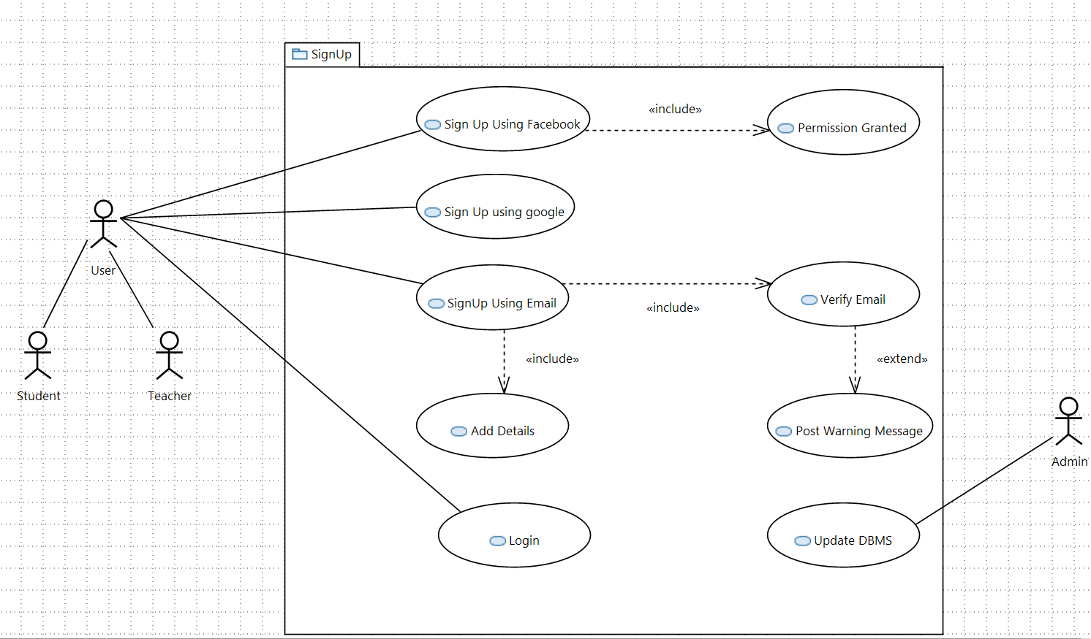

**Class Diagram**

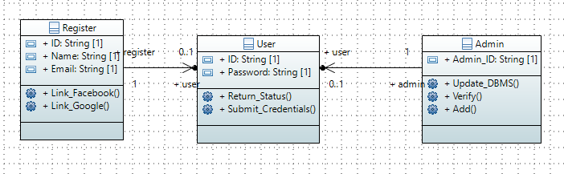

**Sequence Diagram**

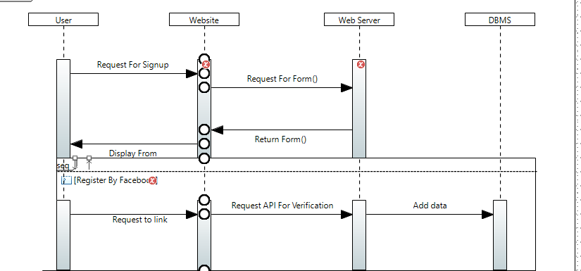

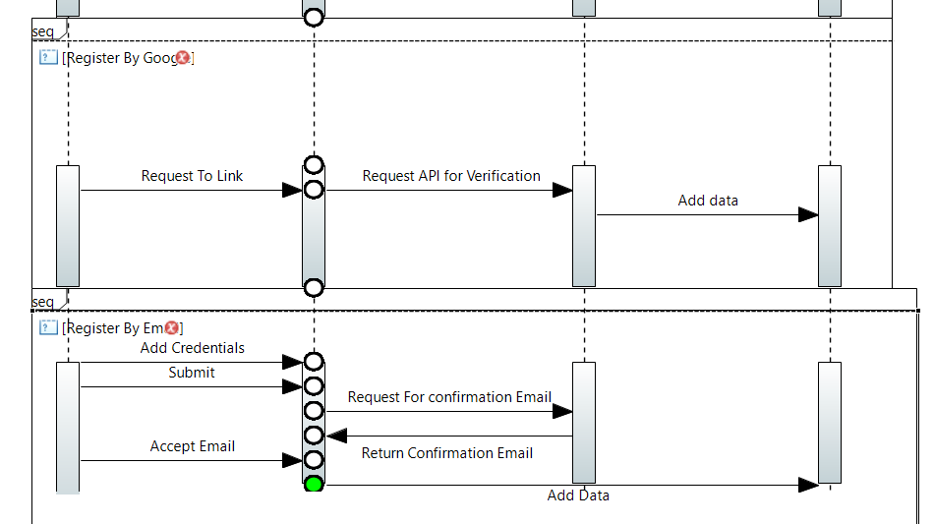

**Activity Diagram**

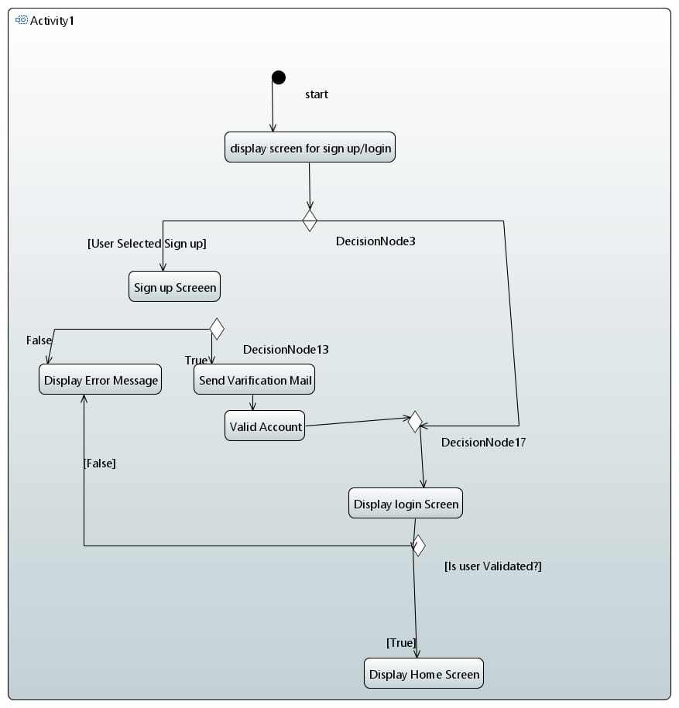

**State-Machine Diagram**

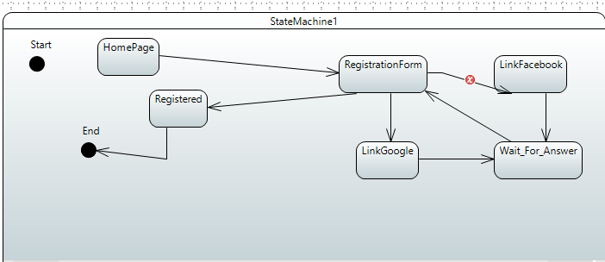

**Communication/Collaboration Diagram**

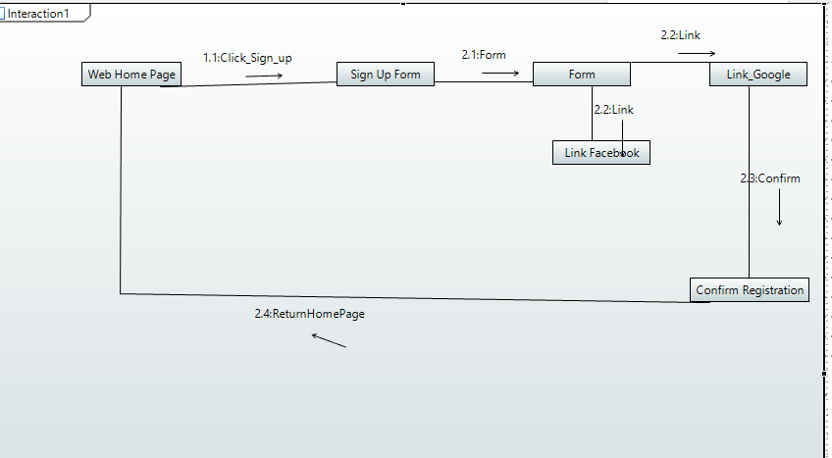

**Timing Diagram**

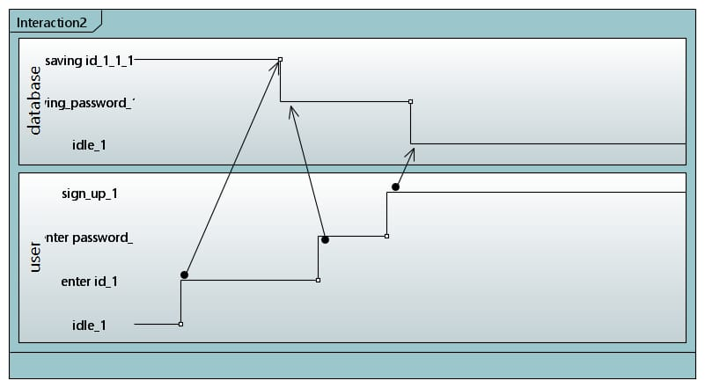

**Non-Functional Requirements:**

* The system should have an easily understandable design in order for users to use it. It should provide the necessary information when the user commits possible errors.
* The system should also consider people with common disabilities and should make possible access to the registration system.
* The System should offer Registration form in multiple Languages.

**Use Case: Enroll**

**Fully Dressed Use Case:**

| **Use case Name** | **Enroll** |
| --- | --- |
| **Primary actor** | **User of the system** |
| **Secondary Actor** | **Web server** |
| **Pre-Condition** | **1) User must have to login** |
| **Post Condition** | **Complete payment** |
| **Trigger** | **Press the Buy Course Button** |
| **Main Success Scenario** | **Buy course, pay amount, course has been added in profile** |

**Use Case Diagram**

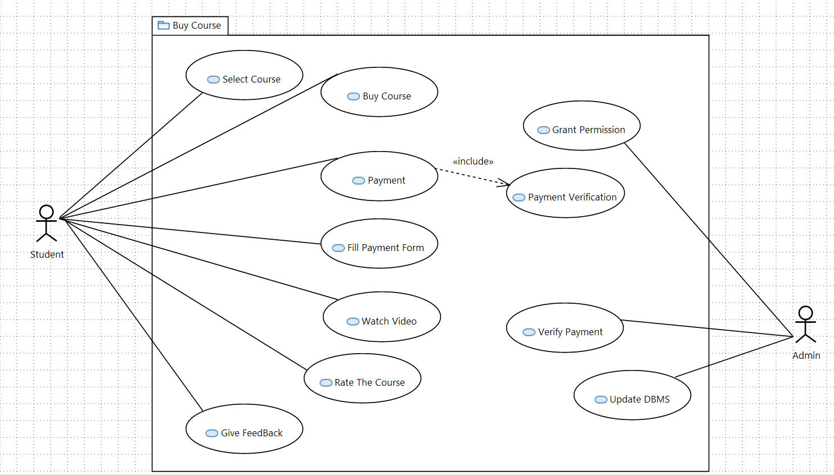

**Class Diagram**

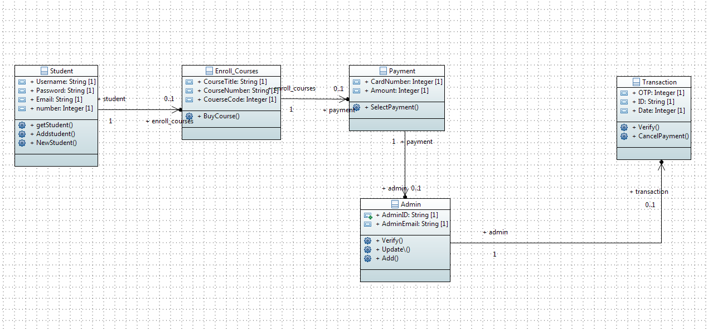

**Activity Diagram**

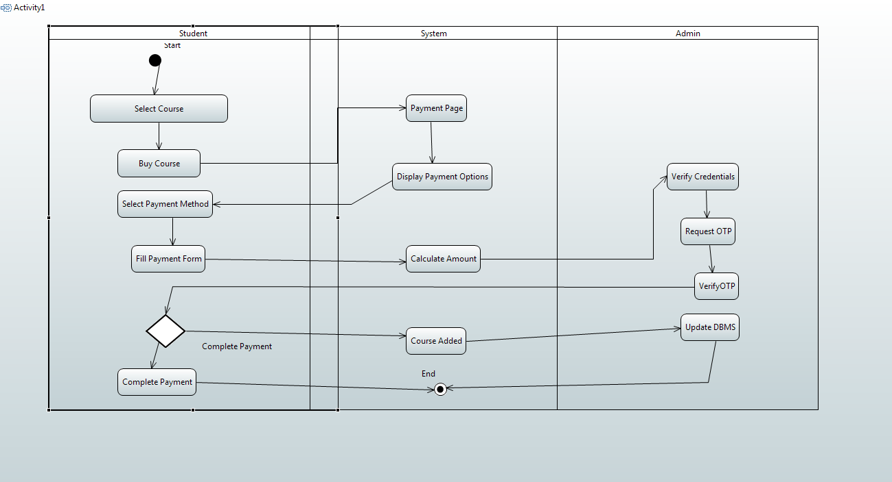

**Sequence Diagram**

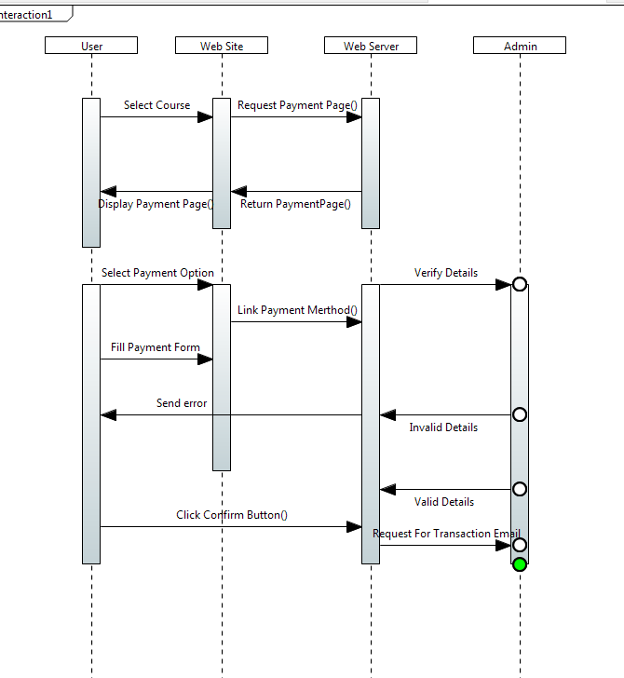

**Communication/Collaboration Diagram**

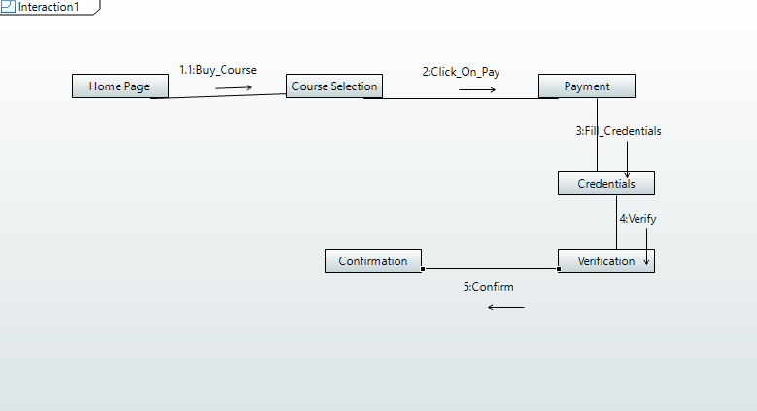

**State-Machine Diagram**

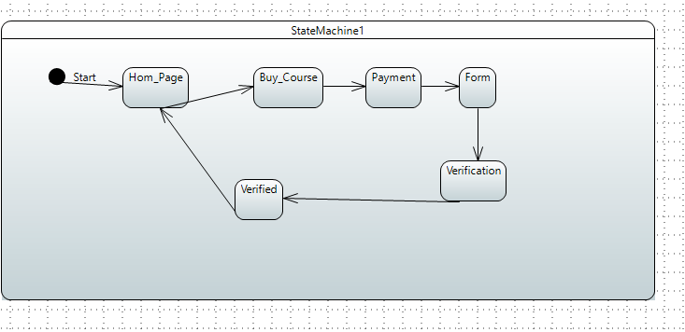

**Non-Functional Requirements:**

* The system must be interactive and the delays involved must be less.
* Information transmission should be securely transmitted to server without any changes in information.
* When the system is disconnected or frozen due to over access at the same time, it should save all the process of the users have made up to the point of abnormal happenings.

**Use Case: Search**

**Fully Dressed Use Case**

| **Use case Name** | **Search** |
| --- | --- |
| **Primary actor** | **User of the system** |
| **Secondary Actor** |  |
| **Pre-Condition** | **1) Have login to system**  **2) Decide what to search** |
| **Post Condition** | **Requested result** |
| **Trigger** | **Press the search button** |
| **Main Success Scenario** | **1) What will click on the search table**  **2) Check if their request data given in different categories.**  **3) Else just enter what he/she want** |
| **Extension/Alternative flow** |  |
| **Exception** | **Requested data is not available** |
| **Quality** | **Find the requested data in 0.01 seconds** |

**Use Case Diagram**

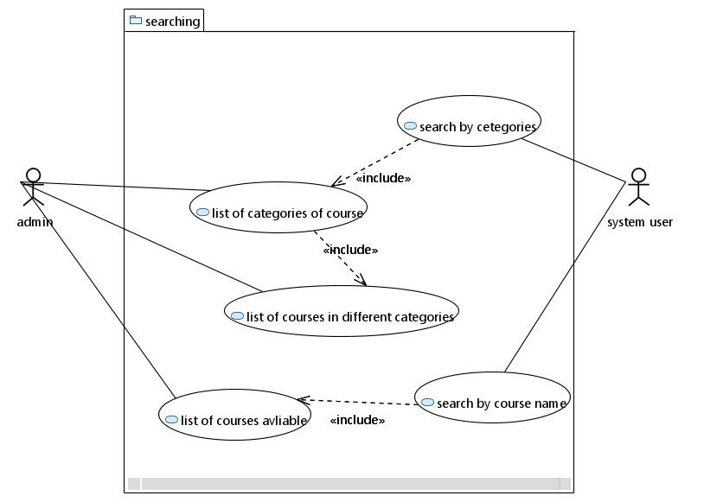

**Class Diagram**

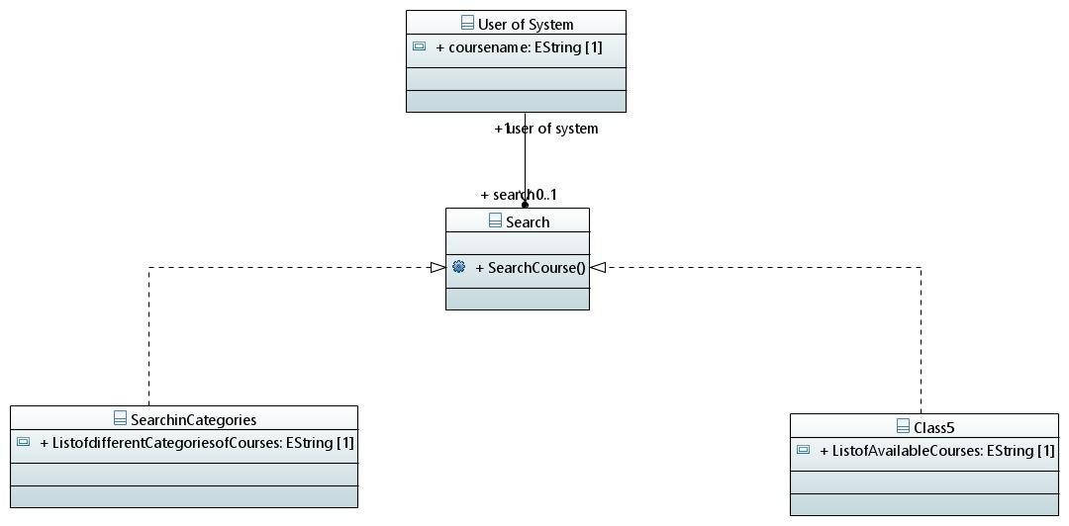

**State Machine Diagram**

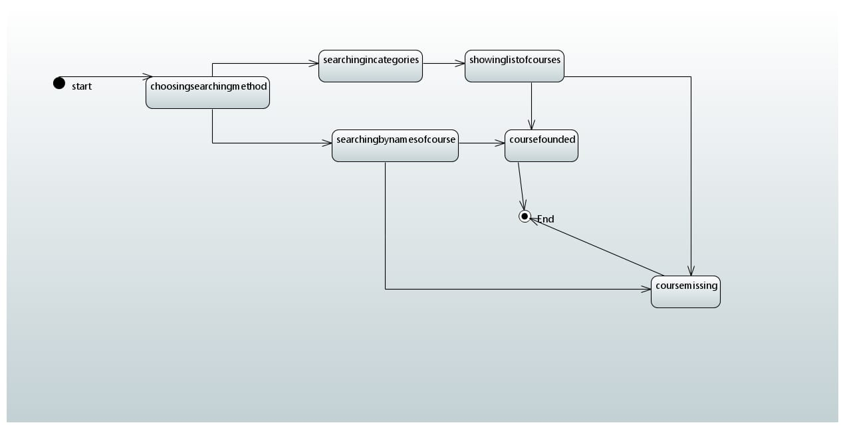

**Activity Diagram**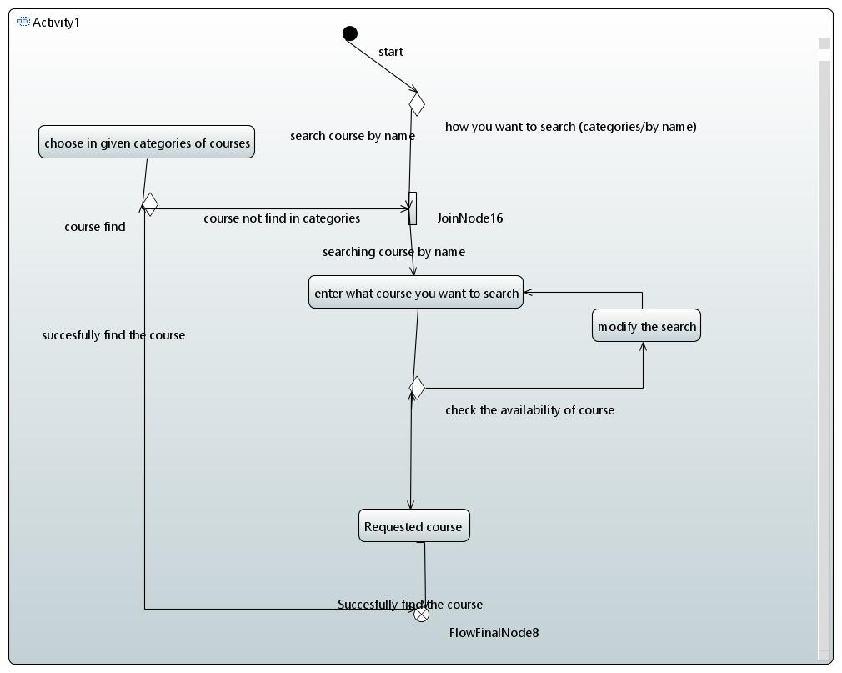

**Sequence Diagram**

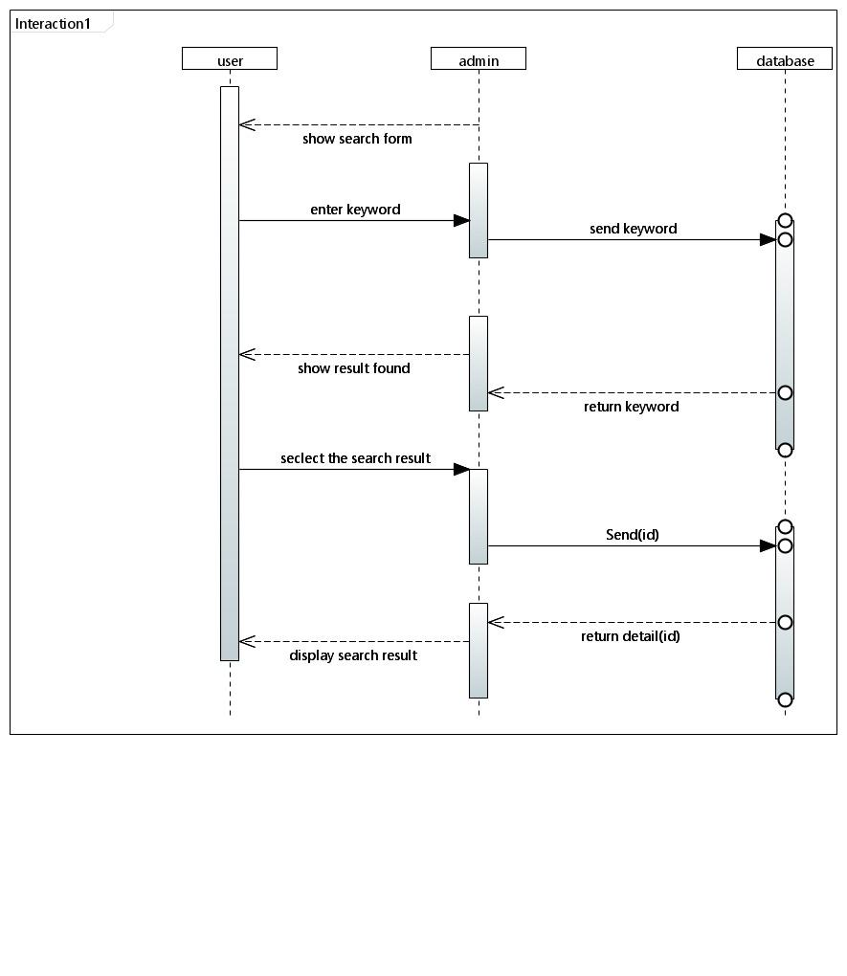

**Collaboration/Communication Diagram**

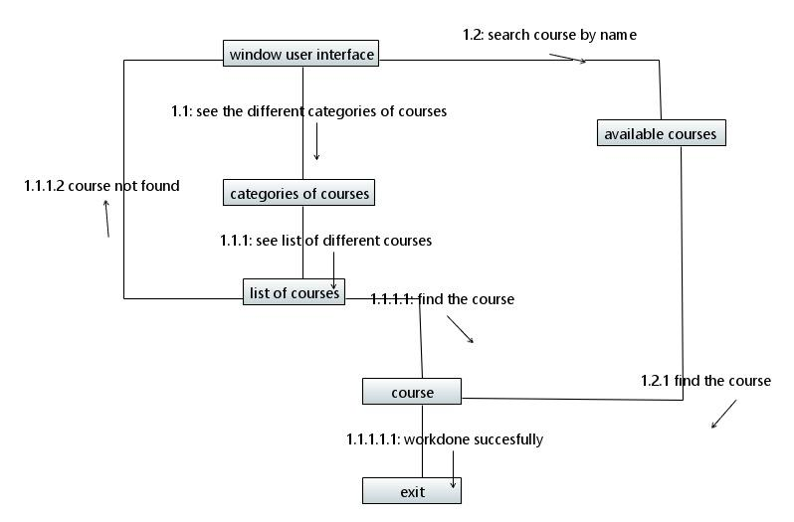

**Timing Diagram**

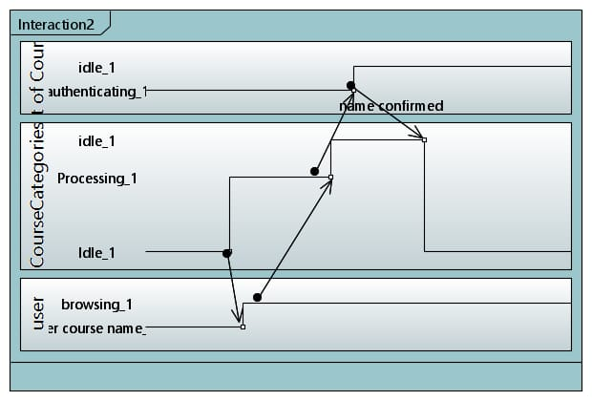

**Use Case: Become a Tutor**

**Fully Dressed Use Case**

| **Use case Name** | **Become tutor** |
| --- | --- |
| **Primary actor** | **User of the system** |
| **Secondary Actor** | **Registrar** |
| **Pre-Condition** | **User Must be registered** |
| **Post Condition** | **Qualified for teaching** |
| **Trigger** | **Press the button “Become a tutor”** |
| **Main Success Scenario** | **There are 3 type of teaching you can perform at this platform:**  **1) By slides**  **1.1) Choose course topic**  **1.2) Course learning objective**  **1.3) Decide how student will practice your work**  **1.4) Create your course outline.**  **1.5) Script your course.**  **2) By videos**  **2.1) Determine what type of video you record.**  **2.2) Gather the Equipment for audio and video recording**  **2.3) Set up recording space.**  **2.4) Send us video test.**  **2.5) Edit you course.**  **3) Special case.**  **3.1) Write your course landing page.**  **3.2) Pick up course price.**  **3.3) Build Social Proof.**  **3.4) Expand to other channel to grow the audience.** |
|  |  |
| **Extension/Alternative flow** |  |
| **Exception** |  |
| **Quality** | **Each step should be well defined** |

**Use Case Diagram**

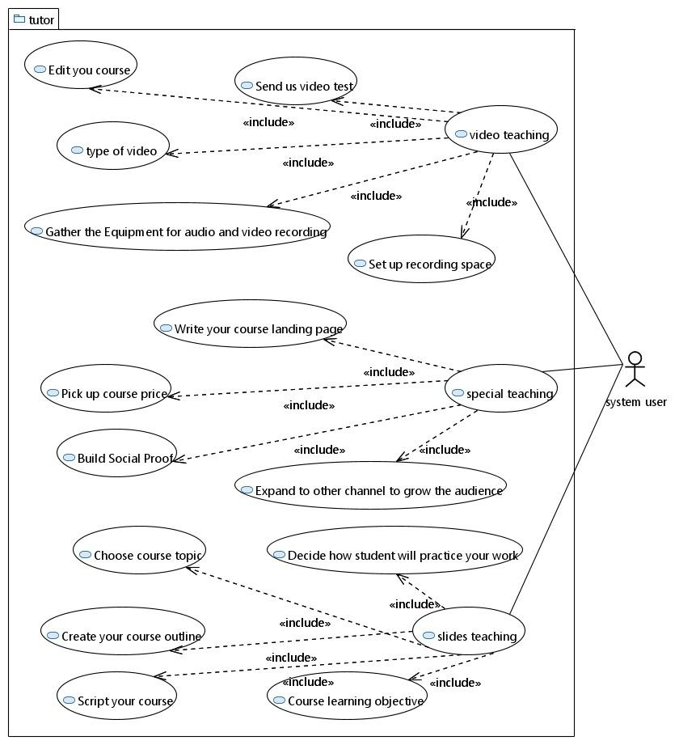

**Class Diagram**

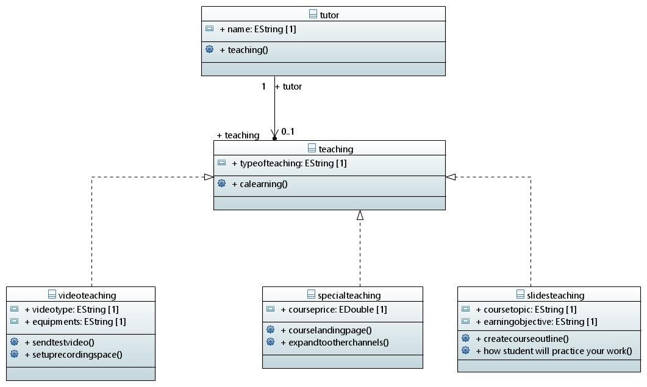

**Activity Diagram**

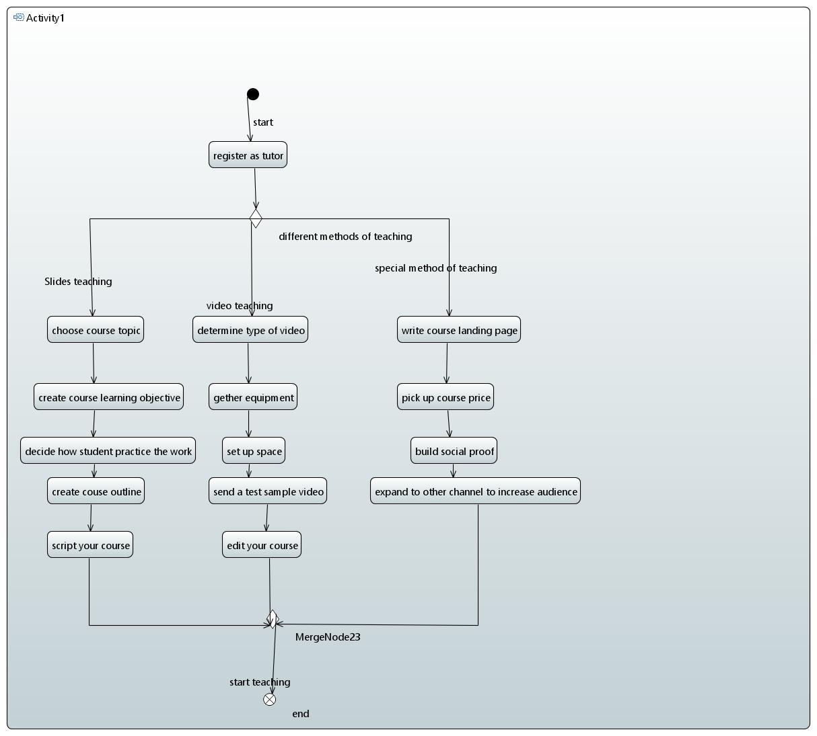

**Sequence Diagram**

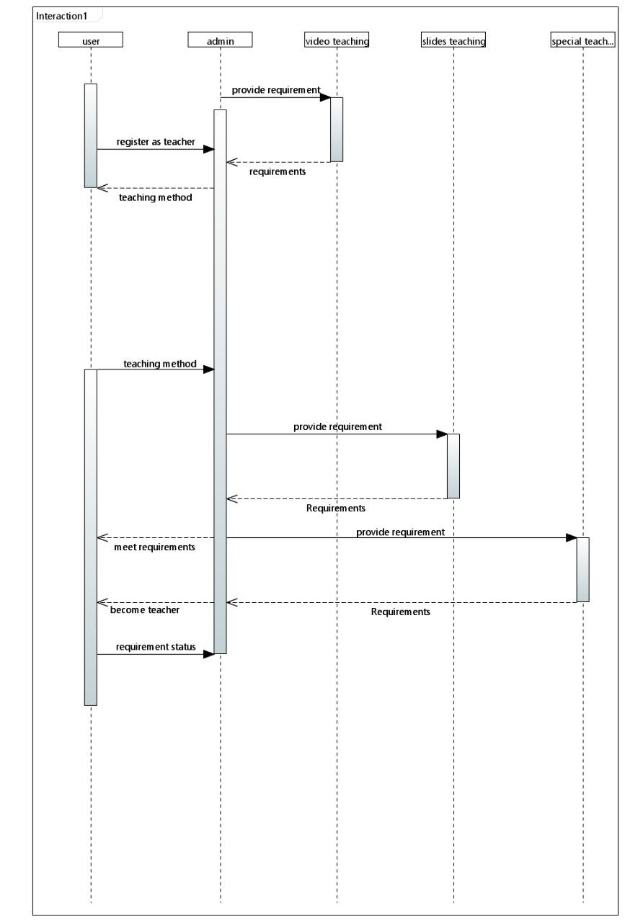

**Collaboration/Communication Diagram**

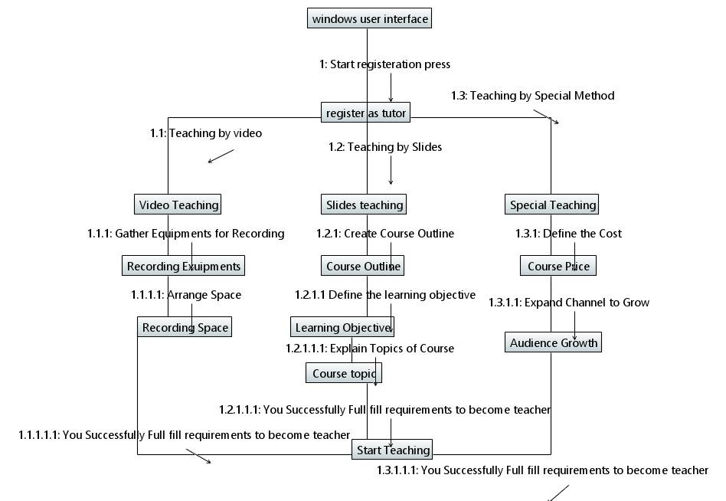

**State-Machine Diagram**

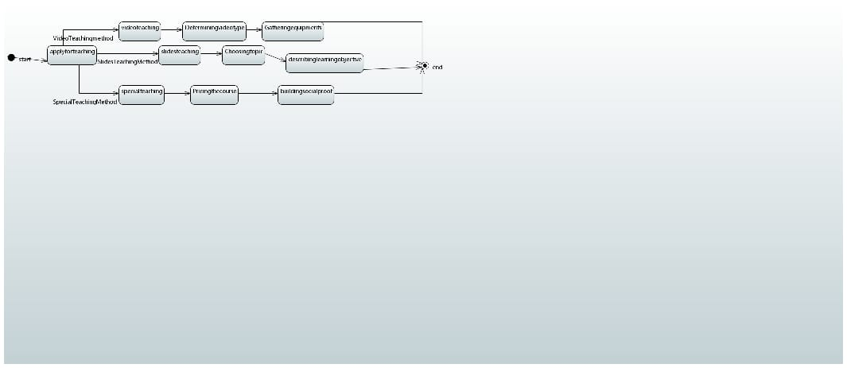

**Use Case: Add to Cart**

**Fully Dressed Use Case**

**USE CASE DESCRIPTION**

| **Name** | **Add To Cart** |
| --- | --- |
| **Actor** | **User, Admin.** |
| **Include** | **None** |
| **Pre-condition** | **User must be login or sign up.** |
| **Main flow** | **1. User first login or sign up**  **2. Use case starts when the user add a course in the cart.**  **3. User then have to add additional details including email address and shipping details.**  **4. The windows open and user have to select the payment method.**  **5. At the end the pop up message display for order confirmation and order confirmed if user select yes.**  **6. Use case ends.** |
| **Post-condition** | **Confirmation email or sms comes.** |
| **Alternate flow** | **User can forgot the password** |
| **Exception** | **If payment is made through debit or credit card and the card declines then “Your Card is declined” message should be shown.** |

**Use Case Diagram**

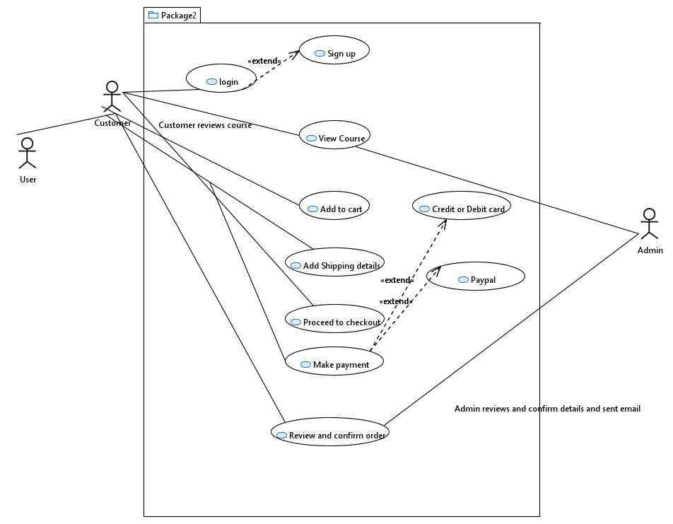

**Class Diagram**

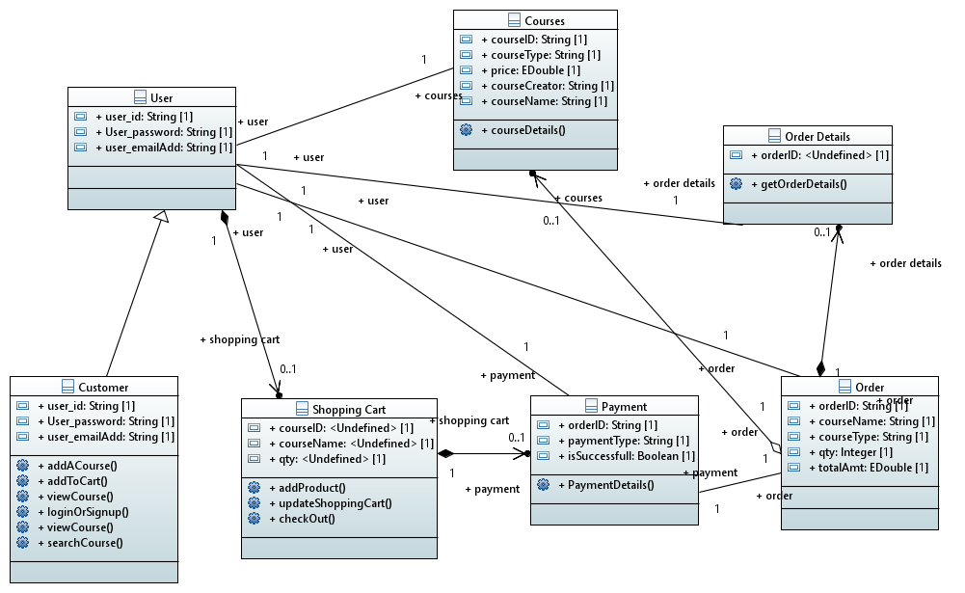

**Sequence Diagram**

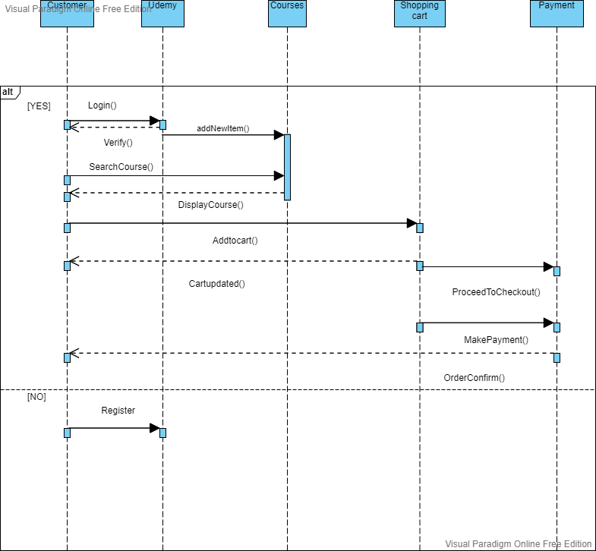

**State Machine Diagram**

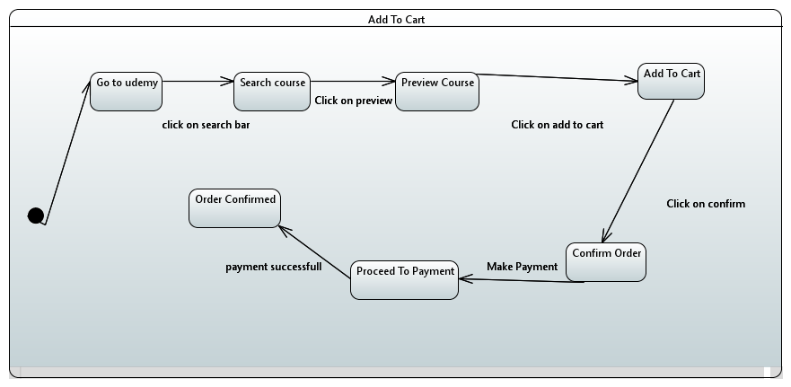

**Collaboration/Communication Diagram**

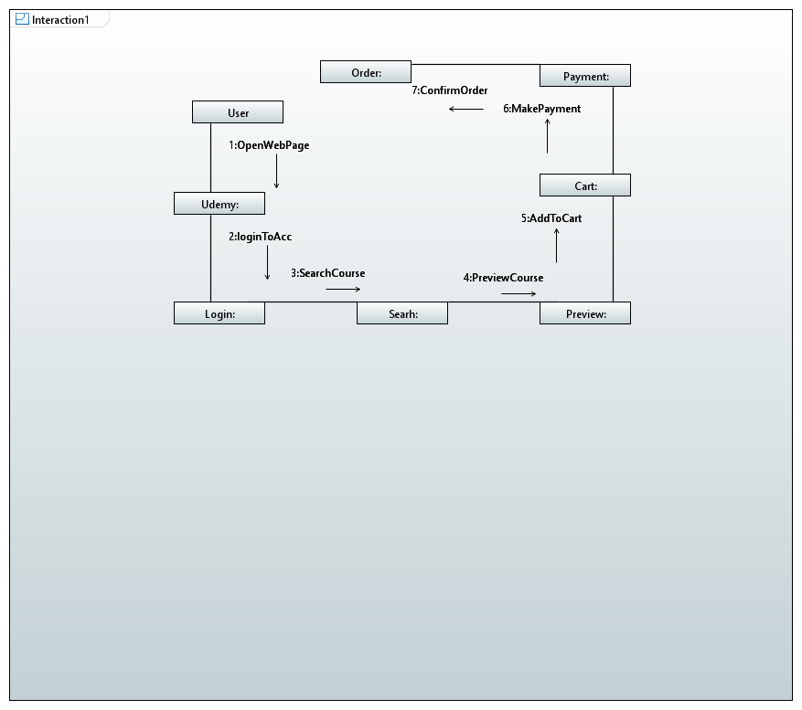

**Activity Diagram:**

